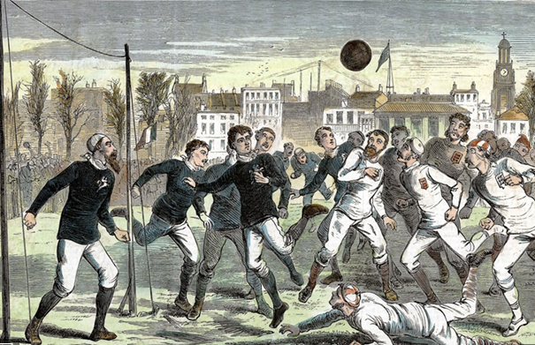

PRE A LEVEL COURSE
IN PHYSICAL EDUCATION
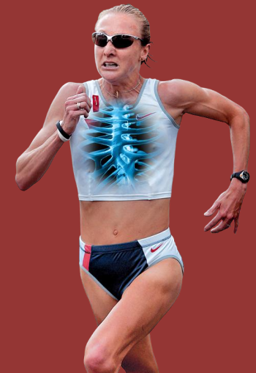
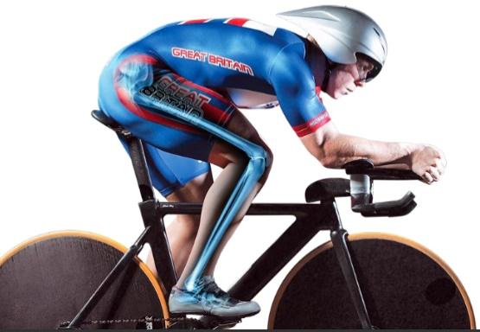
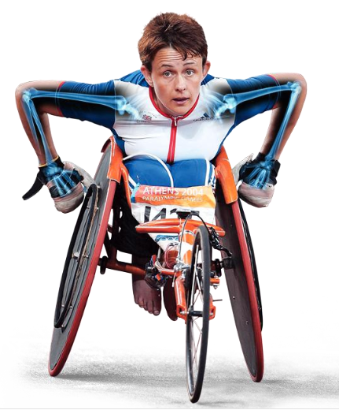
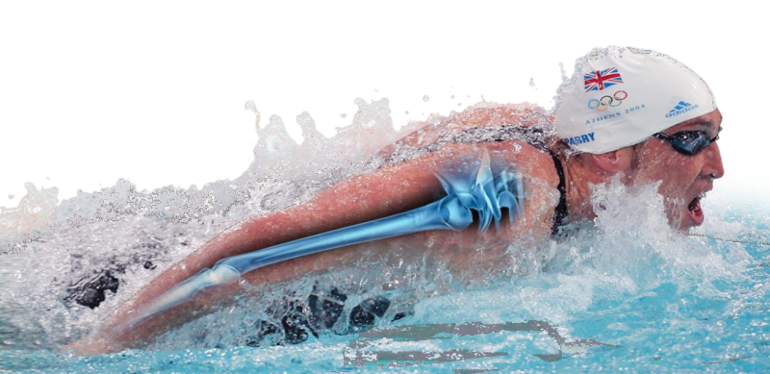

A LEVEL PE COURSE OUTLINE

The course specification can be accessed here (OCR Specification):

Theory: OCR A Level Physical Education Specification H555
(Page 5 onwards described the theory you will be taught)

Practical: OCR AS and A Level Physical Education NEA Guide
(You will need to scroll through the document to find your sport. This will tell you what skills, decision making and physical attributes that will be assessed)

The course is split into distinct areas with three different teachers taking responsibility for each of the following sections:

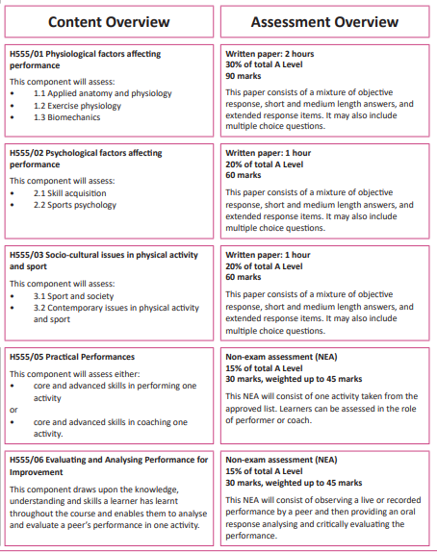
Miss Swan
Miss Swan
Mr Addyman
Mr Dean
Miss Swan

SUMMER TRANSITION WORK

We are so excited to hear that you are hopefully going to be joining us in September to study A Level PE.
This booklet will give you a brief introduction to the course layout and help you to start getting to grips with some of the key terminology and content so that we can hit the ground running in September.

The first term there are 3 topics we will study. These 3 topics will contribute towards the 3 final exams you will sit in the summer of Year 13.

These three topics are:

- Applied Anatomy and Physiology (where we start studying muscles, joints and bones)
- Skill Acquisition/Sports Psychology (where we start looking at coaching methods to help performers learn skills)
- Sport and Society (where we start looking at the History of Sport in the UK and Cultural influences)

We will also be talking to you about your chosen sport and how this is examined as part of your coursework.

Please complete the 4 tasks below and bring this completed workbook with you in September. We have also added some links and information about future Career Pathways in Sport, with links for you to do some research!
Best wishes, Team PE
*SUMMER TRANSITION WORK HAND IN WEEK: 11th – 15th SEPTEMBER

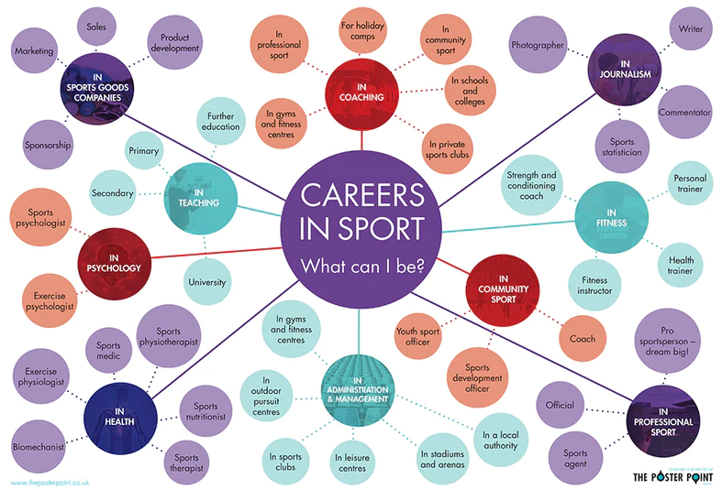
TASK 1: ANATOMY AND PHYSIOLOGY

You will learn about the muscles and bones during the first half term of the A Level PE course.

Learn the names of all of the muscles below. You must know the names of each of these muscles for the final exam. We will test your knowledge of the muscles below during the first few weeks of the A Level PE course.

This information we are learning here is called ‘A01’ (Assessment Objective 1) and its about your Knowledge and Understanding.

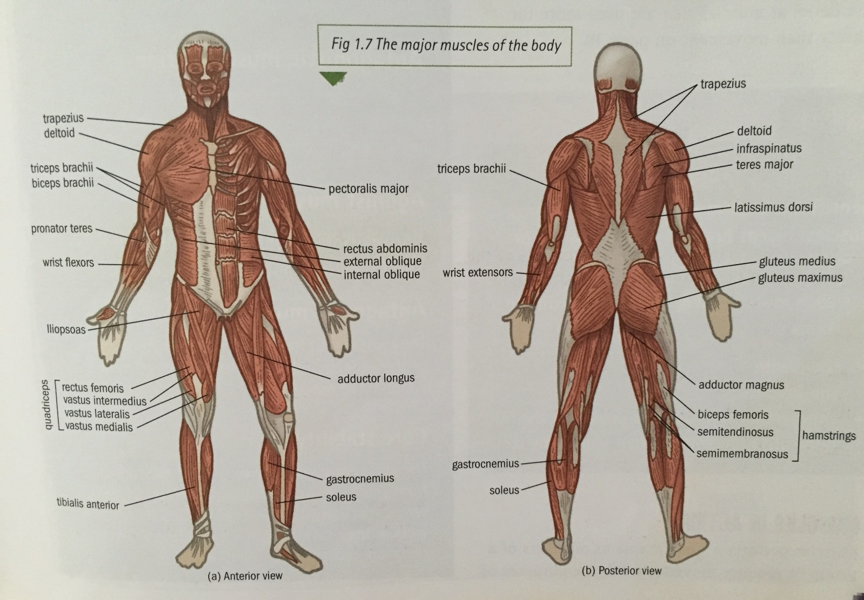

Here is a blank picture to help you to practice learning the muscles. You may wish to print this page out a number of times and practice labelling it to test how many muscles you can remember. Once confident with your A01 Muscles knowledge, complete a final one below and bring into lesson during the first week in September.

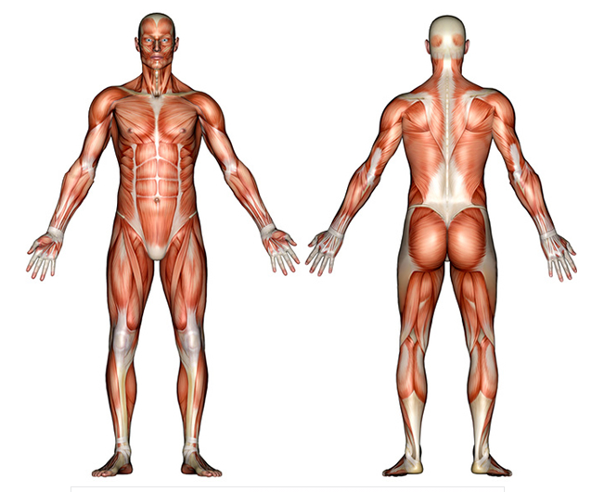

You will also need to know the different bones of the skeleton and what the different joint types are as AO1 knowledge.
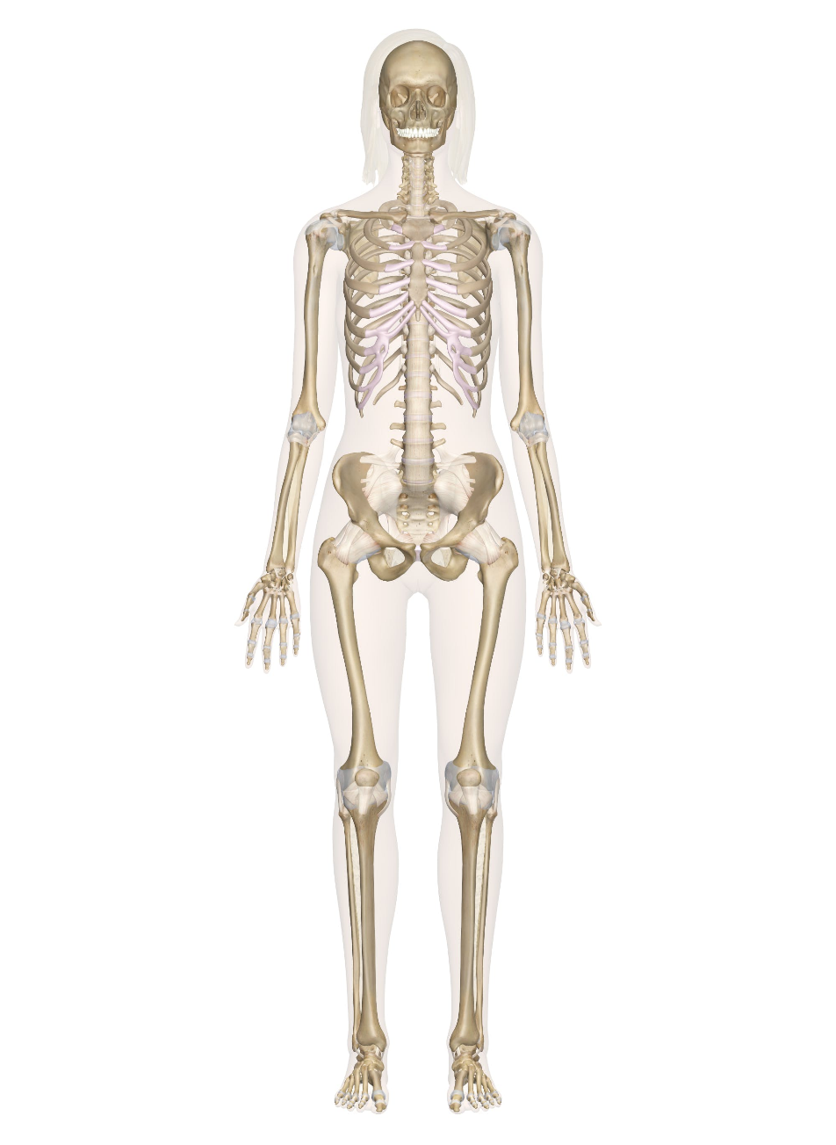
Task 1 Bones of the skeleton: Label as many bones as you can on the skeleton below. Task 2 Joint types: Name the different joint types and the types of movement that can occur at each joint.
Joint type | Movements that can take place

TASK 2 – SPORT AND SOCIETY
Fact Finding research task – On this day? Can you find the answers to this Sports History Quiz?
Write your answers in the spaces provided:
- Annually, on Shrove Tuesday and Ash Wednesday what ‘football’ game has been played in Ashbourne, Derbyshire from at least 1667

- On 6th April 1896, what event opened in Athens, Greece and what individual is considered instrumental in its organisation?

- On 3rd August 1944, what act of parliament became law in the UK and how do you feel this legislation would impact on the participation of children in physical activity.

- On 12th November 1975 what legislation was passed in Parliament that protected men and women from discrimination and what impact do you feel this may have had on the sport in the UK?

- What happened on 29th May 1985 in the Final of the European Cup (Liverpool v Juventus)

- On 29th July 1988, The Education Reform Act bought what compulsory teaching in UK Schools?

- What happened on 15 April 1989 in the Semi Final of FA Cup (Liverpool v Nottingham Forest)

- On 20th February 1992, what competition was founded to maximise the advantage of a lucrative television rights deal?

- On 15th December 1995, what ruling made a profound effect on the transfer of footballers in the European Union? Can you say a little more about it?

- On 19th July 1996, which female athletic event was added to the Olympic Programme in Atlanta. When did men first take part in the event?

- What happened on Friday 26 August 2016 during the anthem of the USA National anthem prior to the start of an NFL game involving the San Francisco 49ers? Who was involved and why is what the athlete is doing significant?

TASK 3 – SPORT AND SOCIETY
Extended reading task: Read the article below on the life of a working-class peasant.
Then answer the questions below.
- Give 3 or 4 adjectives to describe what life was like for the peasants.

- Describe the relationship between the social classes (lords and peasants)

- Describe the traditional gender roles in the family.

- Give 3 or 4 adjectives that could describe how the peasants interacted outside of working hours.

- Describe the provision of education for peasant children.

ARTICLE: - The life of a working-class peasant in the Middle Ages.
Most peasants were serfs who were unable to leave the estate without the lord’s permission. Some peasants were freemen who had more rights and fewer responsibilities to the lord. Both required the lord’s protection and served the lord well.
The peasant’s home was made of logs held together with mud. The roof was thatched with straw. They were generally one room with hole in the ceiling through with heat and smoke cook escape. A peasants’ furniture was sparse, maybe a table and some stools, piles of straw covered with animal skin for beds, and a loom for weaving cloth. There was also a wooden tub, leather jug, iron cooking pots and hooks for hanging poultry and meats. The house was surrounded by a patch of land. The peasant grew his/her own vegetables, fruit trees and raised animals to provide for their food. Animals were important so in the winter they were brought inside the hut to keep them from freezing. Ale or wine was brewed. Bees were kept for honey; salt could be bought, and water was drawn from a village well or the river. Garments were spun from the wool of sheep. Most of the peasants did not have shoes: in cold weather they wrapped their feet in cloth.
A peasant had a short life span of about thirty years. Poor sanitation, poor medical help and lack of medication, and poor diet were contributing factors to a short life span. Cholera, smallpox and typhoid fever were common ailments and killed many. Many babies died at birth or never lived past infancy.
Peasants worked for three days a week for the lord of the manor, and more during harvest time. Crops were sowed by hand; grain was cut with a sickle and fields were ploughed with a crude plough possibly powered by an animal. If this was not the case, farmer and his wife dragged the ploy through the soil. Not only did the peasant work for the lord, he paid him rent. Rents were paid by giving a portion of grain, honey, and eggs that the peasant raised on his plot of land. They also had to give one tenth of all that was raised to the Church.
A peasant typical day may have been something like this. The serf arose, said his prayers, grabbed his clothing and a piece of bread and left his home to meet with other villagers. They waited for their daily assignment from the reeve. The peasant’s wife was not needed in the fields, usually. She stayed at home collecting eggs, feeding the livestock, and milking the cow. After she finished these tasks, she put a wooden yoke with buckets attached to it, on her shoulders and went to the river or well to haul her water for cooking or washing. She weeded the garden, picked vegetable, spun and wove cloth. Wool, linen and flax were spun into clothing. She also spun hemp for sacks and cords. Children worked alongside their mother. They worked in the fields. They helped to tend the animals. There was no formal education except what was necessary for religious instruction. After all the work was finished for the lord, peasants returned home to work their own land. If they were fortunate, they had oxen and maybe a plough to share. Their day ended as the serf sat down to meal of stew, bread and cheese. Soon after the sunset, the serf would go to bed.
Although the workdays were long and heard, there were many holidays on the calendar. Most holidays were determined by Church holy days. At Christmas, peasants celebrated twelve days of leisure and recreation until the Twelfth Night. Another week was allotted to them at Easter and another week at Whitsuntide, seven weeks after Easter. Sundays were always free days. There were also occasional breaks with wakes, market days, fairs, weddings, funerals and public occasions. As you can imagine, a day of celebration meant a welcomed day away from the rigors of hardship and work.
On feast days, the whole community participated together in church rituals. Depending on the type of holiday, certain entertainment and foods were provided. Sporting events were important in keeping all men trim and in good fighting condition. Laws were passed that required able-bodied men to practice archery on Sunday, but these laws were ignored by many young men so that they might play ball games instead! The game was rough, with few rules and no referee. Other sports included wrestling, throwing heavy stones and other feats of strength. Gambling was another form of entertainment and the pub was a gathering place for gossip and game-playing. During the Middle Ages leisure time was characterized by community participation. The entire village gathered for the events described above.
People who lived in the villages needed more than the food that they were able to raise for their survival and comfort. The weekly market was a meeting place for both town and country people. It provided those necessities that would have been unavailable. The lord would bring his crops to sell, local craftsmen would display their wares and peasants would bring their handy work. Early traders supported themselves and accumulated wealth by travelling from village to village, presenting their goods on tables or in open stalls. Bread, meat, ale, meals, candles, cloth, leather goods, wood and metal were some of the wares offered. Trade was important to the survival of the town and merchants realized this early on, and the marketplace was the hub of social life for the village. The village square was transformed into a market on the weekends: the markets were well organized and well supervised events. At some fairs, traders from Venice or Genoa would sell silks and spices. Others would sell different types of wood and leathers. These fairs saw different types of entertainment: jugglers, musicians, puppet shows, bullbaiting, bearbaiting, cockfighting, games and rides, not too different from today’s fairs. Fairs began as a part of the gathering for religious festivals and wakes.

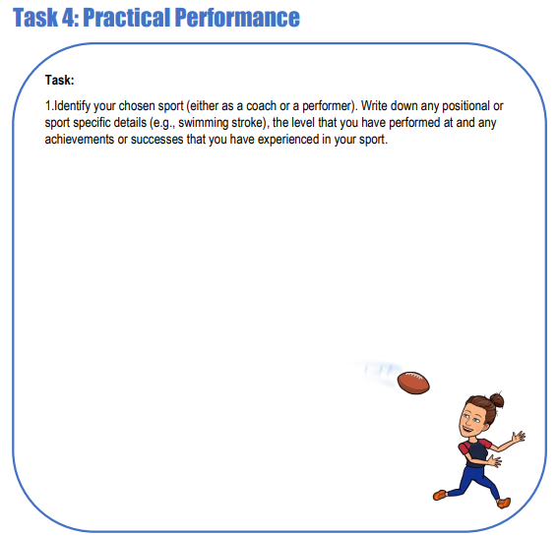

CAREER PATHWAYS IN SPORT
University Pathway:
TOP SPORTING UNIVERSITIES
Loughborough University: Courses | School of Sport, Exercise and Health Sciences | Loughborough University (lboro.ac.uk)
Bath University: Sport courses (bath.ac.uk)
Exeter : University of Exeter | Sport courses | UCAS

SPECIALIST FOOTBALL: UCFB | GIS University Degrees in the Football and Sports Industry

LOCAL AREA
Bournemouth University: Bournemouth University | Sport courses | UCAS
AECC University College: Sport, Exercise and Health Science degree courses | AECC University College Bournemouth | AECC University College | Transforming lives through Health Sciences

CAREER PATHWAY POSTERS (University routes)
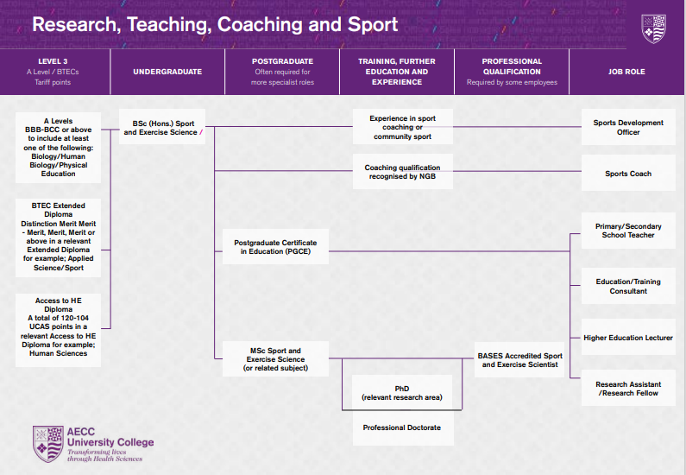

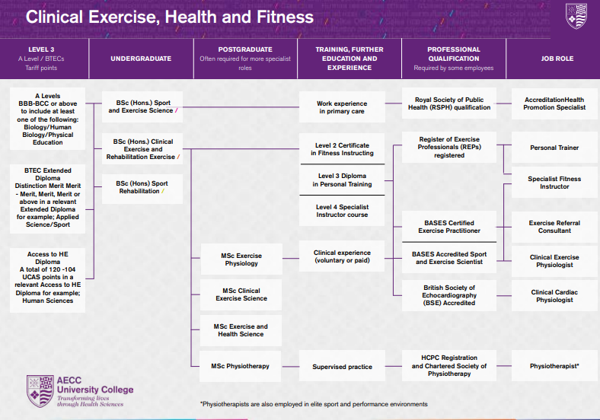
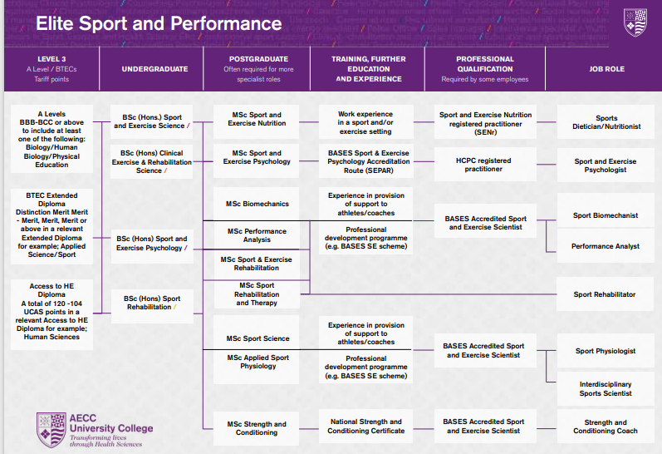

Apprenticeship Routes
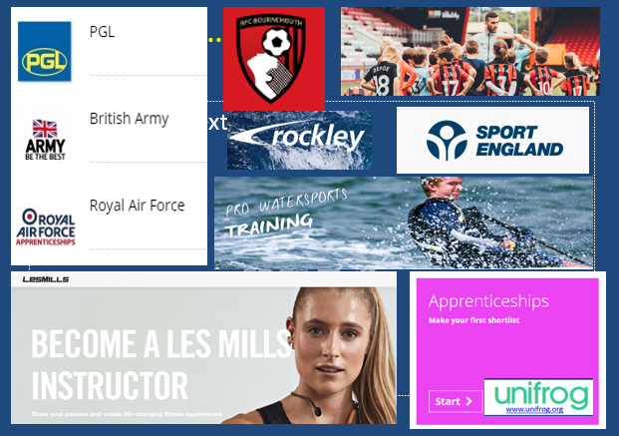
Apprenticeships typically consist of 80% on-the-job training, and 20% studying. For some opportunities this means 4 days per week at the workplace and 1 day at a college, and for others this means you will work for about 10 months a year, then you'll spend 2 months just studying. Sport and fitness apprenticeships | The Apprenticeship Guide
Examples in Sport:
- Coaching
- Personal Trainer
- Community Sport and Health officer
- Exercise and Fitness / Les Mills Instructor
- Leisure Duty Manager
- Leisure Operations Manager
- Outdoor Activity Instructor
- Sporting Excellence: Football / Athletics / Tennis Etc.
- Spectator Safety
Sports Development
Careers Pathways: https://www.uksport.gov.uk/jobs-in-sport/career-pathways
Jobs in Sport: https://www.uksport.gov.uk/jobs-in-sport/search-all-vacancies
